**BUSINESS PLAN**

**Innovator Visa**

Trinity Trading and Consulting Limited

Commodity purchase and shipping algorithm

&

29/03/2023

Abstract

**Table of Contents**

1. Executive Summary 2

1.1. The Business and Background 2

1.2. Innovation 4

1.3. Impact of COVID-19 5

1.4. Financial Forecast 6

1.5. Recruitment Planning 6

2. Description of the Business and Overview 8

2.1. Key Business Information 8

2.2. Key Personnel 9

3. The Problem 10

4. The Solution 13

5. The Opportunity 14

6. SWOT Analysis 16

7. The Competitive analysis 16

7.1. Competitors 18

8. Business Model 19

9. Description of Product 23

10. Marketing Plan 24

11. Risk & Response to Risk 26

12. Financial Analysis 28

# **Executive Summary**

## The Business and Background

**Introduction**

We, Santhosh Krishnamurthy and Gowtham Velusamy have both completed our MBA in International Business and BBA in Information Systems. Through and our academic achievements, hard work and innovative business idea we were both awarded a Startup Visa endorsement from our University. After receiving our visas, we quickly founded Trinity Trading and Consulting Limited in 2021 to envision our novel food purchasing software. We are pleased to report that our Start-up has achieved a turnover of £118,912 within 2 years. We have gained considerable market insights since starting our business and we want to develop a better more disruptive and novel innovation, a **Commodity purchase and shipping algorithm**. We have done our research and no company is doing this in the UK or worldwide, we have only found research papers on this topic.

We want to build a software API (Application Programming Interface) and a compare the market service with this algorithm. This has unique and innovative features that is not currently offered. There exists companies doing Shipping and Transportation APIs and companies doing Commodity trading APIs, but not one that does both.

**API (Application Programming Interface)**

“An application programming interface, or API, enables companies to open up their applications’ data and functionality to external third-party developers, business partners, and internal departments within their companies. This allows services and products to communicate with each other and leverage each other’s data and functionality through a documented interface. Developers don’t need to know how an API is implemented; they simply use the interface to communicate with other products and services. API use has surged over the past decade, to the degree that many of the most popular web applications today would not be possible without APIs.”

For further information please see: https://www.ibm.com/au-en/topics/api

**The Need**

There is a need for Shipping and Transportation Software/APIs, simply googling will produce lots of results of companies providing these services to companies importing products to the UK or in fact every country in the world. The same goes for Commodity trading Software/APIs, it is extremely big business. The UK product imports for 2020 was $610 Billion. <https://oec.world/en/profile/country/gbr>. The potential market is huge. If you have ever ordered a product online in the UK, you will know that it is the combined price of the product and the delivery. It’s the end price you pay that is important to you and is critical in making your purchase decision.

Everybody loves a bargain. If you have ever wanted to purchase a product online, to find it cheaper on one site, but when going to the checkout and after adding delivery charges. The end price is more expensive than a competing site, with a higher product price offering free delivery. This is a simplified approach but the natural human behaviour to get a better price is instinctive. It is also why Amazon provides Free shipping, with prime membership, to entice you to click and purchase with them. Amazon are deliberately removing the delivery expense from your purchasing decision.

Sadly, international trading companies do not provide free international shipping. Imagine trying to discover which rice company in India is selling at the best price, and which shipping company from the various ports has also the best price (excluding all other variables). So, you can work out what is the best end price. Trying to collect all the various product prices and shipping prices from each of all the companies is extremely time consuming for person to perform. Is it the case, do you spend more time searching for a lower prices and lower shipping costs or buy the price you have, with your existing supplier and shipping company. Just be except the higher prices, out of laziness or the cost factor in searching for better prices. Why not have a computer do these calculations and sort them based on best price for you.

The Need comes from purchasers wanting a best product price for delivery to them or a designated destination. Without having the expense and time to figure it out themselves.

**The Solution**

The problem is simple the price of products and price of shipping fluctuates. Getting the best price is extremely difficult to constantly calculate and sort. We want to provide the solution to this timely exercise, that every company importing a product from an international supplier has to perform. We want our company to provide this as service to every company in the UK and then expand to the world. We will build a ‘comparethemarket’ software platform and API that will give our clients access of our best price Commodity purchase and shipping algorithm.We will have a piece of code that can calculate in real time as commodity and shipping availability and prices change. We will have a solution, where companies can quickly discover the best end price for a product they want to import. We will have a solution for Providing a service for best end prices for business selling these products to their customers, with the aim to maximise their profits and maybe pass on some saving to their customers as well.

**The USPs**

Our Unique Selling Point is best described as a ‘comparethemarket’ service for companies buying and importing commodities and products to the UK.

The purchasing and importing of goods to the UK is huge, there are also many large and small companies providing Restaurant Management Software and Food Service Distribution Software. We do not want to compete with them. We want to be a critical cog within the gears of this industry.

We will solely focus on providing a product price and shipping price service to quickly calculate best price. Unique Selling Points this are:

* Provide a quick and easy comparison (comparethemarket) search to discover the best end price in real-time, for a specified product and its shipping to the UK.
* Provide a Software API for 3rd parties companies, so they can integrate it into their software systems seamlessly.

## Innovation

A piece code (algorithm)that operate in a 'comparethemarket' wa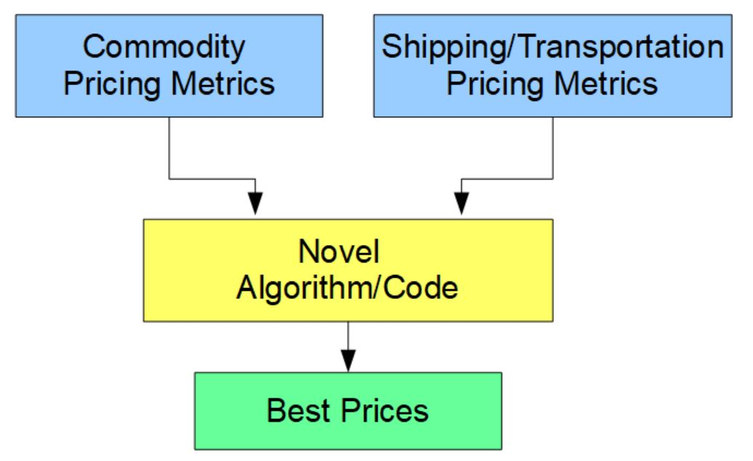y, this will allow key metrics like specific origin, item price and shipping cost to destination, to be factored into a best price. Basically, sorts and ranks these items on their lowest price in real-time and then displays to the client contact information to enable 'Just In Time' purchase. With the eventfully aim of one click purchase agreements. Our clients will have access to multiple sellers and shipping companies. User can further be optimised with additional metrics, like colour, type, weight etc.

This software and service is so unique that we have only found research papers on this topic. Please see:

* <https://www.researchgate.net/publication/279062919_An_Algorithm_for_the_One_Commodity_Pickup_and_Delivery_Traveling_Salesman_Problem_with_Restricted_Depot>
* <https://www.hindawi.com/journals/mpe/2021/9308071/>

Yes, our innovation plan does demonstrate a proficient level of Unique Selling Points. Let us emphasise:

* That separate companies are already providing Shipping and Transportation APIs as a paid service.
* That separate companies are already providing Commodity trading APIs as a paid service.

It is a matter of time that either one of these companies sees this opportunity in the market to combine these services or an innovator like ourselves see this opportunity and develops it.

We have the ambition not only to innovate but have systematically started the preparation groundwork and the building up our resources, with the founding of our Start-up company Trinity Trading and Consulting Limited, when we got the Startup Visa endorsement from our University back in 2021. We both have degrees in IT systems and master’s in business administration, our ambition is to deliver this novel solution. We are confident on our skills that it is obvious by now that this is an extremely viable and scalable product. That we have envisioned this opportunity and are preparing to deliver on this ambitious innovation. That we will make international purchases easier for a lot of companies and disrupt others.

## Impact of COVID-19

The COVID-19 pandemic has had a significant impact on businesses worldwide, causing disruptions in supply chains, changing consumer behaviours, and leading to economic uncertainty. As a startup in the food purchasing and shipping industry, Trinity Trading and Consulting Limited is not immune to these challenges.

One of the major impacts of COVID-19 on our business is the disruption to global supply chains, which has resulted in delays and increased shipping costs. The closure of borders and reduced air freight capacity have also affected the movement of goods, making it difficult to procure commodities from certain regions. Additionally, the pandemic has led to fluctuations in commodity prices, which can make it challenging to offer competitive pricing to our clients.

To mitigate the impact of COVID-19, we have taken several steps. Firstly, we have adapted our supply chain strategies to ensure that we have multiple suppliers and shipping options available to us. This enables us to switch to alternative suppliers and shipping companies if one becomes unavailable or too expensive.

Secondly, we have enhanced our digital capabilities to allow for remote working and virtual communication with our clients and suppliers. This enables us to maintain business continuity and collaboration while minimizing physical contact.

Finally, we are closely monitoring the COVID-19 situation and government guidelines to ensure that we are compliant with all regulations and safety measures. We have implemented health and safety protocols within our office and warehouses to protect our employees and clients.

In conclusion, while COVID-19 has posed significant challenges for our business, we have taken steps to mitigate the impact and adapt to the changing environment. We remain committed to providing innovative and cost-effective solutions to our clients while ensuring the safety of our employees and stakeholders.

## Financial Forecast

**High level Figures**

|  |  |  |
| --- | --- | --- |
| **Year** | **Turnover** | **Profit** |
| 1 | £250,474.49 | -£78,486.51 |
| 2 | £616,366.50 | £23,950.50 |
| 3 | £1,178,712.00 | £344,443.99 |

## Recruitment Planning

|  |  |  |
| --- | --- | --- |
| **Estimate Date** | **Position** | **Total Yearly Salary** |
| Year 1  1-5 months | 1x Front end contractors.  1 x Back end contractors. | £72,000 |
| Year 1  6-7 months | 1 x Front end contractors.  1 x Back end contractors.  1 x Testing contractor  1 x Marketing Manager | £144,000 |
| Year 1  8-9 months | 2 x Front end contractors.  1 x Back end contractors.  1 x Testing contractor  1 x Marketing Manager  1x Sales Executive | £216,000 |
| Year 1  10-12 months | 2 x Front end contractors.  2 x Back end contractors.  1 x Testing contractor  1 x Marketing Manager  2x Sales Executive | £288,000 |
| Year 2  1-12 months | 3 x Front end contractors.  2 x Back end contractors.  1 x Testing contractor  1 x Marketing Manager  3x Sales Executive | £360,000 |
| Year 3  1-6 months | 3 x Front end contractors.  2 x Back end contractors.  1 x Testing contractor  1 x Marketing Manager  3x Sales Executive | £360,000 |
| Year 3  7-12 months | 6 x Front end contractors.  4 x Back end contractors.  2 x Testing contractor  2 x Marketing Manager  6x Sales Executive | £720,000 |

# **Description of the Business and Overview**

## Key Business Information

**Description of the Business and Overview:**

Trinity Trading and Consulting Limited is a UK-based company that specializes in providing a cutting-edge solution to our clients to reduce the *end price* of commodities and products shipped to the UK. The company was founded in 2021 by Santhosh Krishnamurthy and Gowtham Velusamy, who have both completed their MBA in International Business. The primary goal of the company is to revolutionize the way businesses source, purchase and ship commodities, particularly in the food service industry.

|  |  |
| --- | --- |
| **Key Business Information** | |
| Name: | Trinity Trading and Consulting Limited. |
| Founders: | Santhosh Krishnamurthy and Gowtham Velusamy. |
| Year Founded: | 2021 |
| Industry: | Commodity Trading, Shipping and Logistics. |
| Target Market: | B2B clients, specifically Food Service Management Software providers. |
| Product/Service: | Commodity purchase and shipping algorithm through a software API. |
| Turnover  (Within 2 years): | £118,912.00 |

**Unique Selling Proposition:** Develop an innovative compare the market, real-time algorithm that combines commodity trading and shipping, enabling clients to source the best deals on commodities and optimize shipping costs, ultimately saving time and money.

**Revenue Model:** Monthly service fee for access to the commodity purchase and shipping algorithm through the software API, with fees varying based on the number of commodities or products clients want access to.

**Expansion Plan:** Starting with one commodity/product and expanding to more products gradually; replicating the model for other destination countries.

**Intellectual Property**: The code for the Commodity purchase and shipping algorithm, protected through copyright laws and digital rights management systems.

**Location**: United Kingdom

**Reason for Choosing Britain**: The founders have strong ties to Britain, having completed their education and established their first startup in the country. The existing infrastructure, resources, and connections make Britain the logical choice for the development and growth of Trinity Trading and Consulting Limited.

## Key Personnel

The CVs of both Santhosh Krishnamurthy and Gowtham Velusamy clearly reflect their qualifications, skills, experience, and knowledge in their respective areas of expertise. They both have an MBA in International Business, BBA in Information Systems and experience working in diverse industries, which has provided them with a solid foundation in business management, entrepreneurship, and international trade.

Roles of individual team members:

1. Gowtham Velusamy: As the Managing Director of Trinity Trading and Consulting Ltd, is responsible for:
   * Software Development and Integration
   * Web Portal and Mobile App Development
   * Data Management and Analysis
   * System Scaling and Expansion
   * Technical Support and Troubleshooting
2. Santhosh Krishnamurthy: As the Managing Director of Trinity Trading and Consulting Ltd, is responsible for:
   * Financial management and reporting
   * Record-keeping and documentation
   * Payroll and benefits administration
   * Accounts payable and receivable
   * Administrative support
   * Project management

Areas of responsibility are clearly defined for both team members, with Gowtham focusing on the technical aspects of the business and Santhosh overseeing the financial and administrative functions.

The business appears to have the necessary skills to complete its tasks, given the founders' background and expertise in business management, software development, and financial administration.

To address any potential skill shortages and ensure the success of the business, the team could recruit individuals with the following levels of experience and key responsibilities:

1. Business Development Specialist:
   * Identify and develop new business opportunities.
   * Build and maintain relationships with B2B clients.
   * Collaborate with the technical team to ensure product offerings align with market demand.
   * Manage sales and marketing strategies.
2. Logistics and Supply Chain Manager:
   * Develop and implement efficient logistics processes.
   * Oversee shipping and transportation partners.
   * Monitor and optimize shipping costs.
   * Ensure timely and accurate delivery of commodities.
3. Data Analyst:
   * Collect, process, and analyse data from various sources.
   * Monitor commodity prices, shipping costs, and supplier information.
   * Provide insights and recommendations for product improvements and optimizations.
4. Intellectual Property (IP) Consultant:
   * Assist with the protection of the Commodity Purchase and Shipping Algorithm.
   * Provide guidance on copyright laws and digital rights management systems.
   * Develop and implement strategies to safeguard the company's IP assets.

By recruiting individuals with these specific skill sets and experiences, the company can effectively address any potential shortages and ensure that it has a well-rounded and capable team to drive the business forward.

# **T****he Problem**

The problem is the getting the *best end price* of international commodities and products for the purchaser in the UK. It’s the problem every person has in procurement.

In simple terms, navigating from Point A to Point B involves finding the quickest and most energy-efficient route, particularly when driving an electric vehicle to prevent running out of power. Traditional methods like using paper maps can’t be compared to modern GPS navigation, which offers more accurate and efficient guidance.

There are many competing companies to purchase products from and too many shipping companies to evaluate. Then you have all the software solution companies vying and competing to lock clients into their exclusive platforms. Once you are locked in, are you truly getting the best end price? Or do companies give discounted intensives only to increase their prices once you are locked into these systems.

At first these software solution companies may be cheaper than employing staff to manual procure, but how can you quickly check if you are getting a good deal or a bad deal.

Another problem is the cost of Staff. In the UK Procurement staff salary starts at a junior level £20k and reach up to £220k. Please see below detail from salary.com and checkasalary.co.uk. It can get expensive.

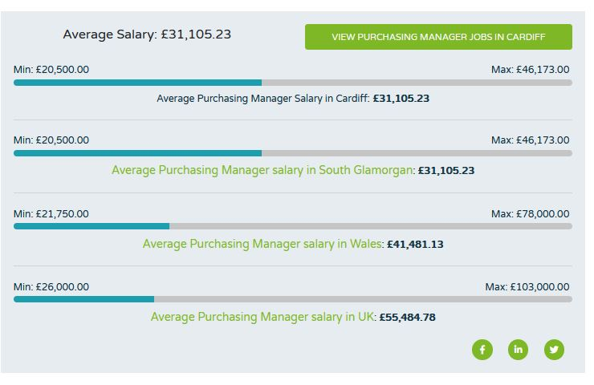

<https://www.salary.com/research/uk-salary/alternate/chief-procurement-officer-salary/uk/birmingham?utm_campaign=google_jobs_salary&utm_source=google_jobs_salary&utm_medium=organic>

[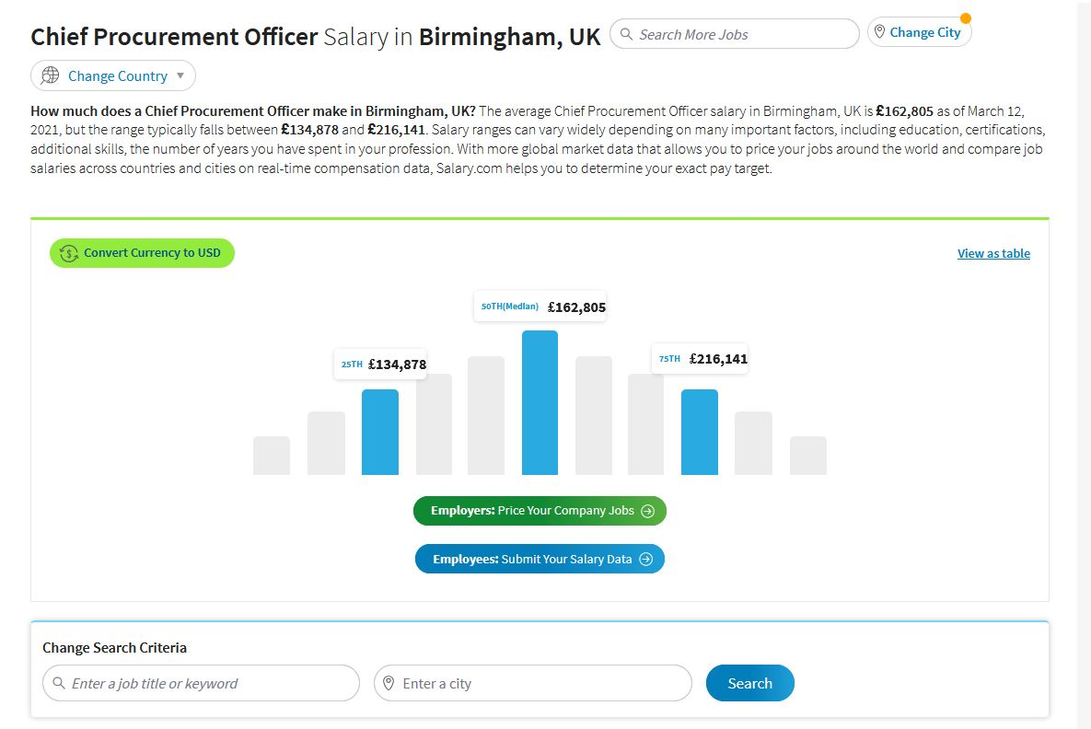https://www.checkasalary.co.uk/salary/purchasing-manager-cardiff?utm_campaign=google_jobs_salary&utm_source=google_jobs_salary&utm_medium=organic](https://www.checkasalary.co.uk/salary/purchasing-manager-cardiff?utm_campaign=google_jobs_salary&utm_source=google_jobs_salary&utm_medium=organic)

**Problems for all the small companies importing goods to UK.**

Small companies have limited resource, struggling on their own and relying on staff knowledge, relationships with suppliers and shippers or outsourcing to fee paying service providers.

How can they quickly check whether they are getting the best end price?

**Problems for all medium, large companies and corporations importing goods to UK.**

Medium, large companies and corporations have the staff and resources to carry out best price checks, their main problem is that it comes at considerable costs.

How can they reduce these costs, keep competitive, maximise profits and check whether they are getting the best end price?

**Problems for all Procurement Service providing companies.**

Procurement Service providing companieshave the staff, resources and have specialised systems in place to carry our best price checks, their main problem is keeping all these product prices and shipping prices up to date. They can outsource and pay two companies a Shipping and Transportation APIs company and a Commodity trading APIs company. They then need to integrate these APIs to their system. Software engineers are not cheap, delivering this is expensive.

How can they reduce these costs, keep competitive, maximise profits and develop a reliable software?

**Problems for all Direct purchases from Local and regional governments organisations and the military.**

Local and regional governments organisations and the military have the similarproblems with large companies. With small orders they have a process to make direct purchases, but with larger orders they need to go through a tendering or vetting process. They can allocate staff resources to price check these processes, but this can get expensive. Governments and the military struggle already with limited resources and budgets.

How can they manage their budgets and resources, reduce their costs, check whether taxpayers’ money is being allocated correctly and not being squandered?

# **The Solution**

The solution our software will provide is quite simple and extremely logical. We will provide a compare the market solution for checking of *best end price* of international commodities and products shipped to the UK.

For clients wanting to get a quick check in real time. They can log on our compare the market platform.

For clients that want to integrate our real time compare the market algorithm, we will have a Software API for them to access or integrate into their 3rd party software.

Our Solution is best explained by looking at other compare the market solution. Like Car insurance and Home insurance. I will call these insurance companies.

Most Insurance companies substantially increase their renewal prices after the contract period ends. Making prices fluctuate. Whether it is an increase in their costs or discount deals that have come to an end or are maximising profits by cleverly taking advantage of people being lazy or too busy. Simply insurance prices fluctuate. Before compare the market solution like:

* <https://www.comparethemarket.com/>
* <https://www.gocompare.com/car-insurance/>
* <https://www.moneysupermarket.com/car-insurance/>
* <https://www.confused.com/car-insurance>
* <https://www.uswitch.com/car-insurance/>

You had to pains takingly phone up insurance companies to get new quotes and make your own comparison. Well, that is if you wanted to save money. Thanks to these compare the market software companies you can within 20 mins find the cheapest insurance quote. If you have saved your details, you can get a quote in minutes.

Now can you do that with rice. How fast can you get a list of 1000 suppliers of rice from India, sorted by lowest end price with the costs of shipping included.

Please go ahead, open your web browser and see how long it takes you to get the top 20 end price quotes sorted by best price, for rice shipped to you from all Indian rice exports to the UK, you have 20 minutes.

You will find that it is more complicated than buying insurance the old way, without the compare the market solution 20 years ago. We want to be the company that provides the compare the market solution for checking of *best end price* of international commodities and products shipped to the UK.

# **The Opportunity**

Our product, a Commodity Purchase and Shipping Algorithm, aims to bridge a significant gap in the market by providing an innovative solution for optimizing the procurement and shipping process for businesses dealing with commodities. By analysing current market research, we have identified a unique opportunity that addresses the challenges and inefficiencies in the existing supply chain, market barriers, and consumer expectations.

**Market Research and Gap in the Market:**

Our primary research, including interviews with stakeholders in the food service management industry, revealed several pain points that our product aims to address. These include the lack of real-time pricing information, difficulties in optimizing shipping costs, and the absence of a comprehensive platform that combines both commodity procurement and shipping.

In our secondary research, we found no company in the UK or worldwide offering a combined solution for commodity trading and shipping. Existing companies focus on either shipping and transportation APIs or commodity trading APIs, but not both. This indicates a significant gap in the market that our product can fill.

**Market Forces and Supply Chain:**

The global food supply chain is complex and fragmented, with numerous stakeholders involved in the production, distribution, and sale of commodities. Market forces such as fluctuating commodity prices, supply and demand imbalances, and geopolitical factors contribute to the inefficiencies in the current supply chain.

Our Commodity Purchase and Shipping Algorithm will leverage advanced technologies, including machine learning and data analytics, to create a more transparent and efficient supply chain. By integrating real-time pricing and shipping data, businesses can make informed decisions and optimize their procurement and shipping processes.

**Market Barriers:**

Market barriers include the resistance to change from traditional procurement and shipping practices, technological limitations, and the need for stakeholder buy-in. Our product will address these barriers by providing a user-friendly platform with customizable features and a clear value proposition, highlighting the cost savings and efficiency improvements for businesses.

**Consumer Expectations:**

In today's fast-paced business environment, consumers expect transparency, convenience, and cost savings. Our product will meet these expectations by providing a platform that enables real-time decision-making, optimized shipping costs, and seamless integration with existing food service management software.

**Market Maturity:**

The market for innovative supply chain management solutions is growing rapidly, driven by the increasing complexity of global supply chains and the need for greater efficiency. The UK market, in particular, has seen significant growth in recent years, with the supply chain management software market expected to reach £1.6 billion by 2025, growing at a CAGR of 11.2% (source: Research and Markets, 2021).

**Primary and Secondary Research Findings:**

Our primary research findings indicate that businesses in the food service management industry are seeking innovative solutions to streamline their procurement and shipping processes. They are willing to invest in technologies that provide real-time data, cost savings, and improved efficiency.

Our secondary research supports these findings, with recent studies and industry reports highlighting the growing demand for advanced supply chain management solutions, particularly in the UK market.

In conclusion, the opportunity for our Commodity Purchase and Shipping Algorithm is significant, as it addresses a gap in the market and meets the evolving needs of businesses in the food service management industry. By leveraging the latest technologies and providing a comprehensive solution for commodity procurement and shipping, our product has the potential to revolutionize the industry and create substantial value for our clients.

# **SWOT Analysis**

|  |  |
| --- | --- |
| **Strengths**   * Unique and innovative: Trinity Trading and Consulting Limited's Commodity purchase and shipping algorithm is unique and innovative, providing a competitive advantage over existing shipping and trading APIs. * Scalable: The business model is highly scalable, allowing for easy replication and expansion into new markets and countries. * Experienced founders: The founders of Trinity Trading and Consulting Limited have completed an MBA in International Business and have gained market insights through their current business operations. * Efficient purchasing: The algorithm optimizes purchases by combining the cost of commodity and shipping, leading to more efficient and cost-effective purchasing. | **Opportunities**   * Growing market: The commodity trading and shipping market is growing, providing ample opportunity for Trinity Trading and Consulting Limited to capture market share. * Global expansion: The scalability of the business model allows for global expansion, potentially increasing revenue streams. * Strategic partnerships: Trinity Trading and Consulting Limited can form strategic partnerships with food service management software providers to increase brand recognition and access to a larger client base. * Diversification of services: The company can diversify its services by adding more products and expanding into other verticals, providing new revenue streams. |
| **Weaknesses**   * Lack of brand recognition: Trinity Trading and Consulting Limited is a new start-up with limited brand recognition, which may impact its ability to attract and retain clients. * Dependence on B2B clients: The success of the business is largely dependent on the number of B2B clients that use the software API, which may be affected by market fluctuations and client satisfaction. * Reliance on technology: The business is heavily reliant on the software API, which may be vulnerable to technical glitches, system failures, and cyber-attacks. * Legal protection: The intellectual property protection of the code for the algorithm may be challenging to enforce in international markets. | **Threats**   * Competition: Trinity Trading and Consulting Limited may face competition from established commodity trading and shipping companies, and new entrants into the market. * Economic instability: Changes in the global economy may impact the demand for commodity trading and shipping, potentially affecting the business's revenue streams. * Legal and regulatory changes: Changes in legal and regulatory frameworks in different countries may impact the business's operations and intellectual property protection. * Technology disruption: Disruptive technologies may emerge that could potentially make the current algorithm obsolete. |

# **The Competitive analysis**

Our main competitors can be categorized into two groups: those providing shipping and transportation APIs and those offering commodity trading APIs. However, none of these competitors offer a single solution that combines both shipping and commodity trading in a seamless API, as we do. This gives us a unique advantage in the market.

**Competitor 1: Shipping and Transportation APIs Examples: Flexport, project44, ShipEngine**

Strengths:

* Established market presence.
* Strong networks with shipping and logistics companies.
* Advanced technology and data analytics capabilities.

Weaknesses:

* Limited to shipping and transportation services.
* No focus on commodity trading.
* Unable to provide a comprehensive solution for both trading and shipping.

**Competitor 2: Commodity Trading APIs Examples: Trading Technologies, CQG, Eka**

Strengths:

* Deep knowledge of commodity markets.
* Established partnerships with trading platforms and exchanges.
* Advanced trading tools and analytics.

Weaknesses:

* Focused solely on commodity trading.
* No integration with shipping and logistics services.
* Inability to provide a comprehensive solution for both trading and shipping.

**Business offering comparison**

Our business is offering a unique and innovative solution by providing a compare the market software platform and combining both commodity trading and shipping services in a single API This allows our customers to optimize their purchasing decisions based on real-time price and shipping data, giving them a competitive advantage in the market.

**Bringing new ideas and innovation to UK and global markets**

Our idea brings a novel and disruptive approach to the market by providing a quick and easy compare the market solution for best end prices and a software API to integrate commodity trading and shipping services to 3rd party vendors. This new solution enables businesses to make more informed decisions and streamline their operations, improving efficiency and profitability. Furthermore, the algorithm's ability to factor in additional metrics such as color, type, and weight enhances the level of customization, making it a valuable addition to the market.

**Vital market and business need**

There is no compare the market solution for international product purchases and shipping available in the market that quickly and clearly sort by best end prices. The is a need for a comprehensive solution that combines commodity trading and shipping services, as existing providers focus on one aspect or the other. Our business fills this gap by providing a single, integrated platform that helps businesses optimize their purchasing and shipping decisions in real-time, saving them time and money.

**Original business with a genuine competitive advantage**

Our business plan is genuine, original, and tailored to meet the needs of the UK and global markets. By developing a compare the market solution and combining commodity trading and shipping services in a single API, we offer a unique solution that provides our clients with a competitive advantage. Our focus on innovation and scalability ensures that we can continue to expand our services and reach new markets, positioning us as a leader in the industry.

## Competitors

As per the information provided, there are no direct competitors currently offering a compare the market solution and commodity purchase and shipping algorithm in the UK or worldwide. However, there are companies offering Shipping and Transportation APIs and companies offering Commodity trading APIs separately.

Companies offering Shipping and Transportation APIs in the UK include ShipStation, Shippo, and EasyPost. These companies provide solutions to manage and automate the shipping and delivery process for their clients. They offer features like real-time rates and delivery options from multiple carriers, label printing, tracking, and returns management. These companies charge fees based on the number of shipments processed or a monthly subscription fee.

Companies offering Commodity trading APIs in the UK include Mintegral, AlgoTrader, and CQG. These companies provide solutions to manage and automate the trading process for their clients. They offer features like real-time market data, trade execution, risk management, and reporting. These companies charge fees based on the number of trades executed or a monthly subscription fee.

Trinity Trading and Consulting Limited's innovation of a Commodity purchase and shipping algorithm would provide a unique advantage over these companies. The algorithm would enable clients to access multiple sellers and shipping companies, while also optimizing for the lowest overall cost, including both the commodity price and shipping costs. This would provide clients with significant cost savings and increase their efficiency in purchasing commodities.

However, Trinity Trading and Consulting Limited may face indirect competitors such as food management software companies that offer closed and expensive systems. These companies may not offer real-time pricing and shipping information, which could result in clients overpaying for commodities. Trinity Trading and Consulting Limited's solution would provide a more cost-effective and efficient alternative for clients. Our aim would turn these indirect competitors into client, by offering to integrate our software API for a monthly service fee.

Overall, Trinity Trading and Consulting Limited's innovation has the potential to disrupt the market and provide a unique advantage over indirect competitors. It is important for the company to continue to research and stay aware of potential competitors in the market.

# **Business Model**

**Value proposition**

The value proposition is the cost in saving our service will provide to our clients. Using our compare the marketplace and purchase and shipping algorithm accessible through a Software API. Clients will save time and money to quickly identify the searched products by best end price for shipping to the UK. We will charge a monthly service fee for access. Fees will vary depending on how many commodities or products our clients want to have access to. The greater the number the more we charge. Our Novel solution and fees are designed to make alternative solution uncompetitive.

**Supplier and customer expertise**

We have already identified Indian international suppliers that can supply to the UK. We have been operating Trinity Trading and Consulting Limited gathering contacts and executing trades since starting in May 2021.

**Logistics and supply chain**

We have identified shipping companies that can shipped from Indian supplier to the UK. We have been operating Trinity Trading and Consulting Limited gathering contacts and executing trades since starting in May 2021.

**Access to Money**

To secure the necessary funds for our business, we will pursue a combination of sources. Initially, we will use our personal savings and the revenue generated from our existing business, Trinity Trading and Consulting Limited, to fund the development of the Commodity Purchase and Shipping Algorithm. In addition, we will explore external funding options such as angel investors, venture capital firms, and government grants focused on technology and innovation. We will also consider participating in startup incubators and accelerators to gain access to mentorship, funding, and networking opportunities.

**Equipment**

Our business model is primarily focused on software development, which requires minimal physical equipment. The essential equipment includes computers, servers, and relevant software tools for our development team. As our business grows, we may need to invest in additional hardware and software to accommodate the increasing number of clients and to maintain the efficiency and reliability of our API.

**Space**

Initially, our team can operate remotely, leveraging the benefits of technology and collaboration tools to work efficiently without the need for a dedicated physical office. However, as our team grows and the need for face-to-face interaction increases, we will consider renting a co-working space or a small office. The UK offers several flexible office space solutions, which will allow us to scale our workspace according to our needs.

**Knowledge**

Both founders have completed their MBA in International Business, providing us with a strong foundation in the necessary business skills and knowledge required to run a successful startup. Moreover, our experience from Trinity Trading and Consulting Limited has given us valuable insights into the industry.

To ensure that we have the required technical expertise, we will collaborate with software developers and data scientists experienced in creating algorithms and API development. We will also consider partnering with universities and research institutions to gain access to cutting-edge knowledge and expertise in the fields of supply chain optimization, machine learning, and data analytics.

**Network**

Our existing network in the UK, built through our academic journey and our previous business, will be invaluable in establishing partnerships with food service management software companies and other stakeholders in the industry. We will also attend industry conferences, events, and networking sessions to expand our network and gain access to potential clients, partners, and investors.

In summary, our business model relies on leveraging our existing resources, expanding our knowledge and network, and utilizing external funding opportunities to develop and scale our innovative Commodity Purchase and Shipping Algorithm. As we grow, we will continue to refine our approach to ensure that we have access to the necessary money, equipment, space, and knowledge to succeed in the market.

**Target customers**

As we will be providing a compare the market service and a Software API to 3rd parties, our potential customer is anybody importing goods to the UK. This is too grand a project to achieve in the beginning, so we are limiting our customer base and focusing on the food industry. Namely exporters from India and Importers in the UK and then branch out to other exporting countries. As mentioned before, we already have active trades since starting Trinity Trading and Consulting Limited in 2021.

Our potential customer could be from any country importing goods to the UK, but as mentioned before this is too Big for us to achieve and is something we can scale to. Specifically, right now will are targeting UK restaurants and UK food distribution and service providers importing food from India. Independent restaurants will pay for our compare the market service and food distribution and service providers will pay our Software API, to be integrated into their food management systems.

**Enticing Customers**

There doesn’t exist a service currently offering a compare the market solution and commodity purchase and shipping algorithm in the UK or worldwide. However, there are companies offering Shipping and Transportation APIs and companies offering Commodity trading APIs separately.

The compare the market service we will have no competition, it will be a very useful tool for our UK customers to quickly identify the best end price.

For potential customers using Shipping and Transportation APIs and companies offering Commodity trading APIs separately. We will entice them into our more cost-effective combined solution, that will be easier to integrate and compatibility wise one API will be easier to maintain than 2 separate API from 2 different providers.

**Product competition**

The compare the market service we will have no competition, so no opposing choice.

For potential customers using Shipping and Transportation APIs and companies offering Commodity trading APIs separately our solution is easier to integrate and compatibility wise one API will be easier to maintain than 2 separate API from 2 different providers. So, a cost saving, less maintenance challenges and compatibility issues for our customers.

**Product need**

We will provide a service for our clients to fulfil the need of quickly discovering *best end price* of international commodities and products for the purchaser in the UK. There does not exist a compare the marketplace for this industry.

For potential customers using Shipping and Transportation APIs and companies offering Commodity trading APIs. Our solution will fulfil our clients need by proving cost saving, less maintenance challenges and compatibility issue.

**Our first sales**

Our software will be packaged and sold as a monthly subscription service, the more items the client want to check for best end price the greater the fees. Our first customers will be our existing clients that we are already trading with.

**Resource requirements**

We already have some of the data required to start developing our software and algorithm. We have an existing sales, trading and distribution setup already. We both have Software IT degrees. So, this is technically achievable with our current resources, but would be slow. To speed up the development and sales we will hire additional staff.

**Pricing structure**

Our pricing structure is based on the more items the client wants to check for best end price the greater the fees. There are two services we are selling.

**Compare the market service**

The compare the market fee of Initially we will charge £29.99 a month subscription fee for any customer to access our web portal and access our compare the market service. Initial we only change a set fee for unlimitedly searches, but may change this by limiting the number of searchers based on a set service packages of searchers and charging additional fees. We will make adjustments prices once we have an established client base.

**API Service**

The API service is aimed at companies interested in integrating our compare the market service with their software. We will charge £3,000.00 a month subscription fee for access our compare the market service. We will Initial charge a set fee for unlimitedly searches, but may change this by limiting the number of searchers based on a set service packages of searchers and charging additional fees. We will make adjustments prices once we have an established client base.

**12-month action plan**

Month 0-3 Planned start date January 2023

* Go through skills requirements to hire/contract Developers.
* Create scope of development work required Algorithm.
* Create scope of development work required Software API.
* Create scope of development work required Compare the market web portal.
* Create scope of development work required back-end systems.

Month’s 4-12 June 2023

* Hire/Contract developers.
* Start developing Algorithm.
* Start developing Software API.
* Start developing Compare the market web portal.

Month’s 12-24 January 2024

* Continued development and create prototype Algorithm.
* Continued development and prototype Software API.
* Continued development and prototype Compare the market web portal.
* Start selling to existing clients.
* Client feedback driven software development.

Month’s 25-36

* First external sales/clients.
* Clients feedback loop for product improvement prototype Algorithm.
* Clients feedback loop for product improvement Software API.
* Clients feedback loop for product improvement Compare the market web portal.
* Continue developing.

**Market size, viability, growth and scaling**

This business has huge potential for size, is extremely easy to scale and to replicate this model. We will start with 1 commodity/product and create the commodity purchase and shipping algorithm for it. This will lead to the creation of the compare the market software and the Software API for 3rd party vendors. Once we have all the data for specific commodity/product and added to our platform. We will expand by adding more products one by one, growing our range. Once we have completed this for the shipping destination for all imports to the UK from India. We will then replicate these imports to UK from another destinations. Just doing the UK import market is a massive undertaking. After UK our long-term goals is to replicate this with the other 195 countries in the world.

This is an extremely viable, easy to scale and the potential market is ginormous.

# **Description of Product**

**Current status and stage of development**

Our novel Innovation is a commodity purchase and shipping algorithm. From this we will create 2 products.

**Product 1**

We will provide a compare the market solution for checking of *best end price* of international commodities and products shipped to the UK.

Our product functions will allow customers to compare end prices on a number of commodities and products from destinated countries shipped to the UK. Then sorted and ranked by lowest price. This will be a website customer can log into and selected the commodity and shipping destinations in the UK and quickly calculate the end price they pay, with the lowest price ranked first. User can further be optimised with additional metrics, like colour, type, weight etc. Our platform will display the contact information for both the supplier and international shipper so user can complete the trade. Our software system will work in real-time, as and when the lowest priced suppliers run out of commodities or Shipping companies meet their capacity, they will be removed from their ranking to be replaced by the next lowest ranked providers.

**Product 2**

Our second product will be a Software API. This will have the same functions as the compare the marketplace, without the web site log on. This Software API will allow 3rd party vendors to integrate their software system with ours and gain access to all the function for their clients to access and a subscription paying service.

|  |  |
| --- | --- |
| **Current status and stage of development.** | Development has not started, only preparations work has been started. |
| **Demo.** | We have no demo available, but one day yes, we will create a demo. |
| **Minimum Viable Product.** | Not available. |

# **Marketing Plan**

I. **Executive Summary**

Our marketing plan will focus on raising awareness about our innovative compare the market Commodity purchase and shipping algorithm and driving B2B client acquisition. We will leverage both online and offline channels to reach our target audience effectively. The plan's key components are listed below, along with their associated costs, which will be accounted for in the financial forecast.

II. **Market Segmentation and Targeting**

Our primary target market comprises food service management software companies and businesses involved in food and commodity trading. We will focus on reaching decision-makers within these organizations, including CEOs, CTOs, and supply chain managers.

III. **Marketing Objectives**

Raise awareness about our innovative software API and its unique features.

Acquire a minimum of 25 B2B clients within the first year of launch.

Generate positive word of mouth and referrals from satisfied clients.

IV. **Marketing Strategies and Tactics**

A. **Online Marketing**

**Search Engine Optimization (SEO)**

Optimize our website for search engines to rank higher in search results.

Cost: £2,000 for initial optimization and £500 per month for ongoing maintenance.

**Content Marketing**

Create informative and engaging blog posts, whitepapers, and case studies to showcase the benefits of our software.

Cost: £1,000 per month for content creation and promotion.

**Social Media Marketing**

Build a presence on LinkedIn and Twitter to engage with industry professionals and share relevant updates.

Cost: £500 per month for social media management.

**Email Marketing**

Develop a targeted email campaign to nurture leads and convert them into clients.

Cost: £1,000 per month for email marketing software and management.

**Pay-Per-Click (PPC) Advertising**

Run Google Ads and LinkedIn Ads targeting decision-makers in our target market.

Cost: £2,000 per month for ad spend and campaign management.

B. **Offline Marketing**

**Trade Shows and Conferences**

Attend industry-specific trade shows and conferences to network with potential clients and showcase our software.

* National Convenience Show
* Foodex
* IFE
* Speciality & Fine Food Fair
* The Big Hospitality Expo
* PPMA Total Show
* Lunch
* The Ingredients Show
* Imbibe Live
* Cake International

<https://www.displaywizard.co.uk/top-food-drink-trade-shows-exhibitions-uk/>

Cost: £10,000 per year for event fees, booth setup, and travel expenses.

**Print Advertising**

Place ads in relevant industry magazines and publications to increase visibility among our target audience.

Cost: £1,500 per month for print advertising placements.

**Direct Mail Campaign**

Send out targeted direct mail pieces to a list of potential clients.

Cost: £1,000 per month for printing, postage, and mailing list rental.

**Public Relations**

Collaborate with a PR agency to secure media coverage and generate buzz around our software API.

Cost: £3,000 per month for PR agency fees.

V. **Marketing Budget and Forecast**

Our total marketing budget for the first year will be £90,000. This includes both online and offline marketing expenses. As our business grows and our client base expands, we will re-evaluate our marketing budget to ensure it aligns with our evolving needs and goals.

VI. **Monitoring and Evaluation**

We will track key performance indicators (KPIs) to assess the effectiveness of our marketing efforts, including website traffic, social media engagement, email open and click-through rates, the number of leads generated, and the number of new clients acquired. We will adjust our marketing strategies and tactics as needed to optimize our results and achieve our objectives.

# **Risk & Response to Risk**

**1 Risk: Market Competition and Adoption**

Impact: Reduced market share and revenue

Level: Moderate

Actions:

* Continuously monitor the market for new competitors and emerging technologies.
* Develop a strong marketing strategy to emphasize the unique value proposition of our software API.
* Establish partnerships with key players in the food service management software industry to facilitate quicker adoption of our solution.
* Regularly update and enhance the algorithm and software API to maintain a competitive edge and improve user experience.

**2. Risk: Technological Challenges and Delays**

Impact: Delayed product development, increased costs, and loss of potential customers

Level: Moderate

Actions:

* Hire experienced and skilled software developers and data analysts to ensure efficient development.
* Implement agile project management methodologies to address any technical challenges promptly.
* Conduct regular risk assessments and project reviews to identify any potential bottlenecks and proactively address them.
* Allocate resources for research and development to keep up with technological advancements.

**3. Risk: Regulatory and Compliance Issues**

Impact: Legal penalties, loss of credibility, and increased costs

Level: High

Actions:

* Consult with legal experts to ensure full compliance with relevant regulations in the UK and other target markets.
* Implement robust data protection and privacy measures to adhere to data protection regulations, such as GDPR.
* Regularly monitor changes in regulations and update company policies accordingly.
* Educate employees about compliance requirements and the importance of adhering to them.

**4. Risk: Intellectual Property Infringement**

Impact: Loss of competitive advantage, legal disputes, and financial damages

Level: Moderate

Actions:

* Consult with intellectual property lawyers to protect the algorithm and software API through copyright laws and digital rights management systems.
* Monitor the market for any potential infringement of our intellectual property.
* Develop a contingency plan to address any legal disputes related to intellectual property infringement.
* Educate employees about the importance of protecting intellectual property and avoiding any potential infringement of others' intellectual property.

**5. Risk: Economic Fluctuations and Currency Risks**

Impact: Fluctuating revenues, increased costs, and potential losses

Level: Low

Actions:

* Monitor economic trends and market fluctuations to anticipate any potential risks.
* Diversify revenue streams by expanding the product range and entering new markets.
* Consider implementing currency hedging strategies to minimize the impact of exchange rate fluctuations.
* Maintain a strong financial reserve to address any unforeseen economic challenges.

# **Financial Analysis**

**Sources of Investment**

We will both invest £50,000 each and seek further funding for development and launch of our Commodity purchase and shipping algorithm, we will approach a combination of angel investors, venture capital firms, and potentially government grants focused on innovation and start-ups.

**Salary and Sustainability**

During the initial development phase, both Santhosh Krishnamurthy and Gowtham Velusamy will be working full-time on the business. The founders will do their best to not take a salary until the company can afford it. Our goal will be to develop and grow the business. We have factored in a nominal salary of £5,000 per annum for emergencies, but we dot not expect to access this.

**Maintenance Income and Working Capital**

We are currently aware of the working capital needs during the start-up phase of the business and have the necessary maintenance income to cover our personal living expenses. This will enable us to focus on the development and growth of the business without any additional financial burden.

**Revenue Generation Timeline**

We anticipate revenue generation to start within six months from the initial development and launch of our Commodity purchase and shipping algorithm. This will allow for three months of software development and testing, followed by three months of marketing and client acquisition efforts.

**Insurance Costs**

We have included insurance costs in our expenditure projections, covering professional indemnity insurance, public liability insurance, and any other necessary insurance policies. The estimated annual insurance cost will be £5,000.

**Marketing Costs**

The marketing budget will be allocated according to the P&L, with a focus on online marketing channels such as social media, search engine optimization, and targeted advertising. This budget will be adjusted and scaled as the business grows and requires increased marketing efforts.

**Compliance with UK Regulations**

We have carefully considered all the financial requirements of the business, including taxes, pensions, and other UK regulations. We will ensure compliance with these requirements by seeking professional accounting and legal advice as needed.

**Legal fees, Taxes and 3rd party fees**

Legal fees, Taxes and are set by governments and 3rd parties. These are generally set annually or changed thorough legislation or 3rd parties have processes and software to allow changes as they are made in real-time. We will implements processes and functions into our algorithm to make adjustments to allow for real-time compare the market prices. Our indirect competition already do this with their 3rd party Shipping and Transportation APIs and Commodity trading APIs. We in a sense are interrogating both these functions into one compare the market service and see no hindrance in resolving these Legal fees, Taxes and 3rd party fees hurdles, it is just a case of correctly factoring them into our equations.

**Realistic Projections**

The financial projections for our business are realistic and achievable, particularly in the first year. We have conducted thorough market research and competitor analysis to inform our projections, and we believe our innovative approach will enable us to gain a strong market presence.

**Investment Allocation**

Please see P&L

**Expenditure Costs**

The initial costs for our business are realistic and clearly identified, based on our market research, competitor analysis, and knowledge of the industry. By keeping our expenditures lean and focused, we will be able to maximize the impact of our investment and drive the success of our innovative Commodity purchase and shipping algorithm.

**Profit and Loss**

**Summary of Year 1, 2 & 3**



**Year 1**



**Year 2**



**Year 3**



**Break Even**

We expect our first sales in month 5 of the 1st year. We expect to break even in the 2nd quarter of year 2. As revenues come in, we will adjust our investment strategy. We will priorities our resources in the 1styear more towards growth and scaling our business and will consider reinvesting more of our profits. We will focus on hiring more staff and improving our products to expand our business further and generate more revenues. We will also hire the services of intellectual property and legal experts in the 3rd year and expect to take a hit in profits at the beginning of that year. In Year 2, we will focus on breaking even and stabilising of revenues, until we can create a comfortable amount of funds in our accounts. At the second half of year 3 we will ramp up investment to expand our business further.